Water Resources Allocation in Central Chile

Field Reconnaissance and Hypothetical Allocation Tools

Submitted by

List authors alphabetically

# TABLE OF CONTENTS

TABLE OF CONTENTS 2

LIST OF TABLES 3

LIST OF FIGURES 3

EXECUTIVE SUMMARY 4

INTRODUCTION 5

BACKGROUND AND METHODS 6

LOCATION 6

PRECIPITATION 8

SOIL PHYSICAL PROPERTIES 11

RECONISSANCE METHODOLOGY 13

ALLOCATION METHODOLOGY 13

PETORCA VALLEY – A CASE STUDY 16

APPENDIX 21

# LIST OF TABLES

Table 1. Rainfall Depths at Juan Santa Maria International Airport in January 2017. 11

# LIST OF FIGURES

Figure 1. Overview map of Chile. The class spent entire reconnaissance in Central Chile in and near Valparaiso 7

Figure 2. Agricultural Regions. Aconcagua, Casablanca, and Maipa were visited on field trips. Aconcagua Valley is used as the LP Model Framework. 8

Figure 3. Annual Rainfall Map for Costa Rica. from: http://costa-rica-guide.com/travel/weather/weather-map-rainfall/ 9

Figure 4. Rainfall Depth - vs- Month Polar Plot for San Jose' Metro Region 10

Figure 5. Rainfall Depth vs. Month Polar Plot for Arenal Volcano 10

Figure 6. Rainfall Depth vs. Month Polar Plot for Central Pacific Coast 10

Figure 7. Rainfall Depth vs. Month Polar Plot for Central Valley Region 10

Figure 8. Soil Map for Costa Rica. 12

# EXECUTIVE SUMMARY

words

# INTRODUCTION

words

# BACKGROUND AND METHODS

Background intro

## LOCATION

Figure 2 is a map of Chile . The middle third of the map corresponds to Central Chile. The class studied entirely in Central Chile, specifically near Valparaiso and Santiago.

**Figure 2** is a map closer to the study area showing the primary valleys in the area. The class went on field trips to Aconcagua, Casablanca, and Maipo valleys. The allocation case study is based on observations in Aconcagua Valley, but the generalizations are extensible to the other valleys.

Casablanca valley differs from the other two because it does not have a river (surface water expression) that exits the valley. The entire functional water supply in the valley is derived from groundwater.

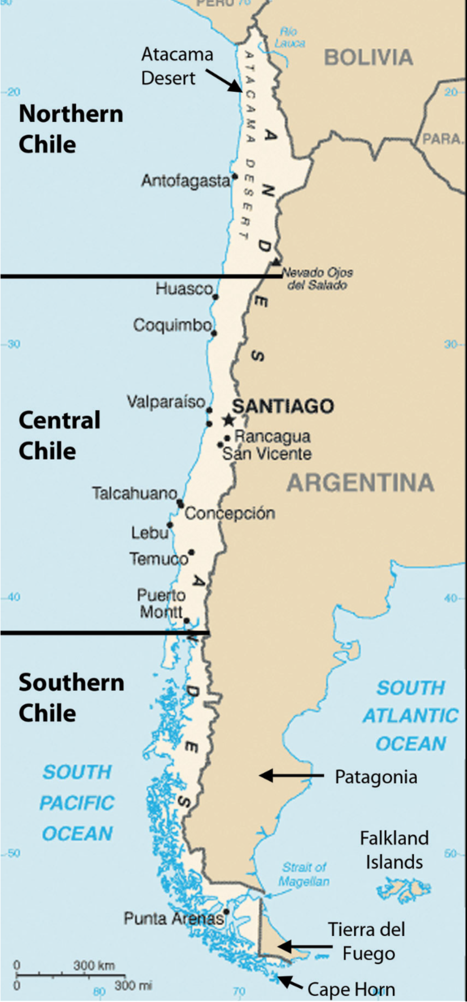

Figure 1. Overview map of Chile. The class spent entire reconnaissance in Central Chile in and near Valparaiso

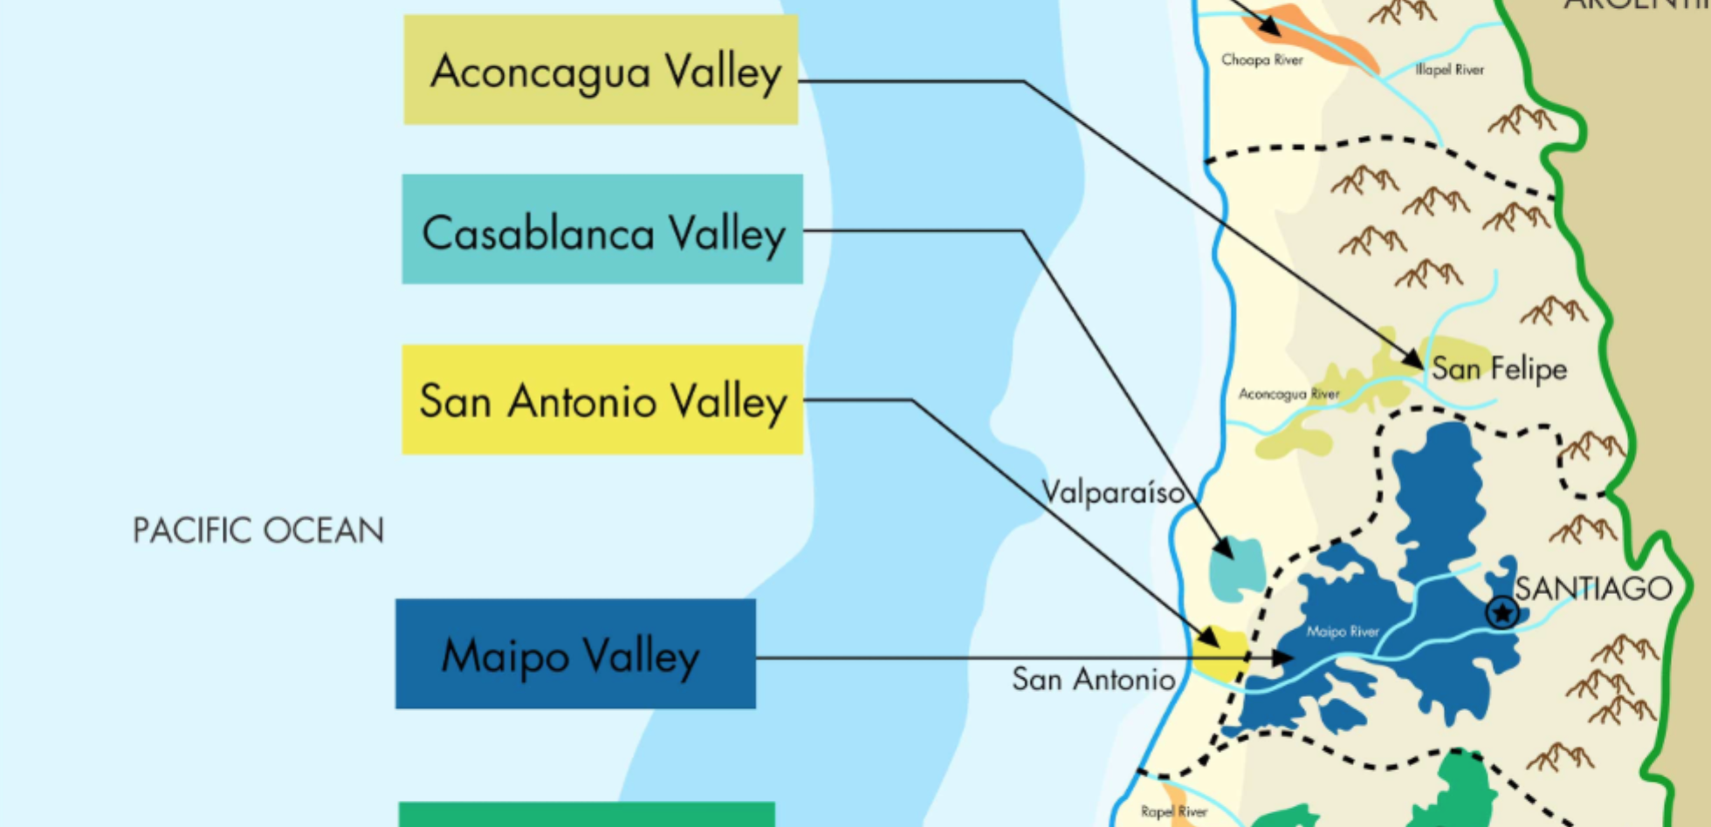

Figure 2. Agricultural Regions. Aconcagua, Casablanca, and Maipa were visited on field trips. Aconcagua Valley is used as the LP Model Framework.

The North side of Aconcagua is dominated by a mountain range, and the most notable mountain is La Campana, which overlooks much of the valley.

## PRECIPITATION

Long droughts are common in Central Chile, and during the visit, the region was exiting from a decade long drought. In central Chile, starting from the Santiago region, the climate becomes almost **Mediterranean** in the narrow strip of plain, that is, mild and rainy in winter, and warm (or hot) and sunny in summer. Along the coast, however, the influence of the sea makes the summer cool: in **Valparaiso**, the average temperature goes from 17.5 °C (63.5 °F) in January and February, to 11.5 °C (52.5 °F) in June and July.

Table 1 is a listing of average precipitation along the coast. The pattern shows evidence of a wet and dry season; the dry season spans nearly ½ the year.

Table 1. Precipitation in Central, Coastal Chile.

|  |  |  |  |  |  |  |  |  |  |  |  |  |  |
| --- | --- | --- | --- | --- | --- | --- | --- | --- | --- | --- | --- | --- | --- |
| **Valparaiso** | **Jan** | **Feb** | **Mar** | **Apr** | **May** | **Jun** | **Jul** | **Aug** | **Sep** | **Oct** | **Nov** | **Dec** | **Year** |
| Prec. (mm) | 0 | 0 | 5 | 15 | 55 | 85 | 110 | 60 | 25 | 10 | 8 | 1 | **373** |
| Prec.(in) | 0 | 0 | 0.2 | 0.6 | 2.2 | 3.3 | 4.3 | 2.4 | 1 | 0.4 | 0.3 | 0 | **14.7** |
| Days | 0 | 0 | 1 | 2 | 9 | 9 | 8 | 8 | 5 | 2 | 1 | 0 | **45** |

Table 1 is a listing of average precipitation in Santiago, about 100km inland from the coast. The pattern is nearly the same; the total depth is about 10% less than at the coast.

Table 2. Precipitation in Central, Inland Chile.

|  |  |  |  |  |  |  |  |  |  |  |  |  |  |
| --- | --- | --- | --- | --- | --- | --- | --- | --- | --- | --- | --- | --- | --- |
| **Santiago** | **Jan** | **Feb** | **Mar** | **Apr** | **May** | **Jun** | **Jul** | **Aug** | **Sep** | **Oct** | **Nov** | **Dec** | **Year** |
| Prec. (mm) | 0 | 1 | 3 | 10 | 40 | 70 | 85 | 50 | 22 | 13 | 9 | 2 | **313** |
| Prec.(in) | 0 | 0 | 0.1 | 0.4 | 1.6 | 2.8 | 3.3 | 2 | 0.9 | 0.5 | 0.4 | 0.1 | **12.3** |
| Days | 0 | 0 | 1 | 3 | 5 | 7 | 7 | 6 | 5 | 2 | 1 | 0 | **37** |

FIGURE XX is a table of climate classification versus precipitation and evapotranspiration. Using this figure, the climate in the study region would classify as Arid – indicative that water availability will be a long-term issue; hence the need for management tools.

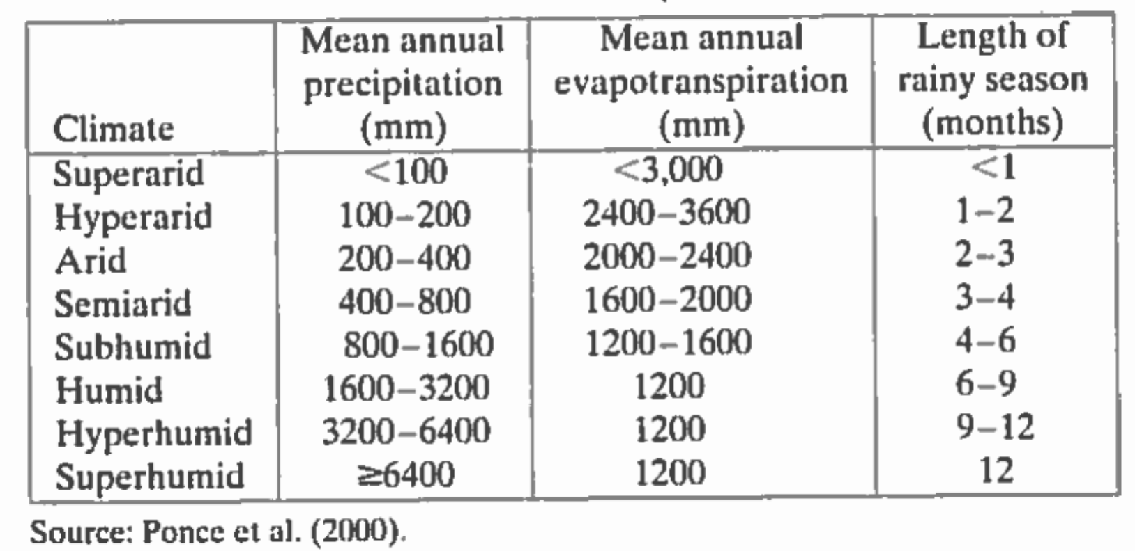

Figure 3. Climate Classifications

## SOIL PHYSICAL PROPERTIES

Soil mapping in Chile is ongoing. FIGURE XX is an image showing the soil texture in the region. The study area is comprised of soils of 20% Clay, 30% Silt and the remainder sandy materials. This texture would be expected to be well draining. The soil has moderately low carbon content.

In the actual field study areas the presence of the river environment and steep hillsides suggests the bottom lands are alluvium. The hillside components are unknown, but on the La Campana field trip the exposed rock appeared to be metamorphic, much like the greywacke, shale, and chert along the California coast.

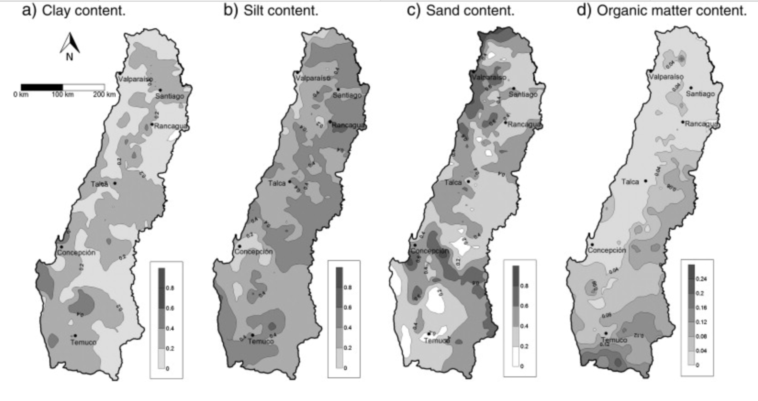

Figure 4. Central Chile Soil Properties

Figure 6. Soil Map for Costa Rica.

.

## RECONISSANCE METHODOLOGY

The team performed reconnaissance studies of the various locations indicated on Figure. The reconnaissance comprised making the following observations

1. Field observation using notes and photography to document various features relevant to water resource allocation.
2. Preparation of daily trip reports to capture perishable observations.

The reconnaissance sites are grouped into two categories: destination/pristine and urban. The one beach visited is more urban than pristine, but is classified as destination for this report.

## ALLOCATION METHODOLOGY

In parallel with the reconnaissance trips, lectures focused on economic evaluation of resources and readings on welfare[1] economics were conducted to build a computational framework for future extension (using real data when available).

Linear Programming as implemented in R was implemented in the framework tool to learn how such allocations can be made with sufficient information.

As part of future allocation, the class participated in the collection of tree-core samples, their preparation for analysis, and in the analysis. These samples represent a way to extend the limited historical record in Chile for estimating water availability in the case study basin.

# FIELD TRIP REPORTS

Jhjhl;h;lkj;lkj;lkj

## Valpariso

Cultural ecozones. Water not an issue. Water supply by pumping to hilltops, gravity to bottom areas at port. Maintenance because of weak soil structure, steep hills, and dense infrastructure is an issue.

## La Campana

Trip from coast to 900M elevation to collect tree cores as part of a dendrohydrologic campaingn to reconstruct historical weather pattersn.

## Casablanca Valley

Trip to commercial winery. Water supply is entirely from groundwater resources. The valley also produces other components than wine grapes.

## Petorca Province (Aconcagua River Valley)

The first stop was on the road to a farm. The instructor from PUCV talked to us about how there were large and small producers across the valley, and the small producers were at a disadvantage when it came to irrigating their plants. The avocado tree is a large part of the agriculture business here, and most of the farmers produce them. These trees require a large amount of water, thus using much of the groundwater supply. When we arrived at the first farm, we were told about the process of obtaining water, and that all water in this area is gathered by well from up to 60 meters below the surface. The farmer mentioned of one experience with the government where a paper was filled out incorrectly and the government denied him any access to water until the problem was resolved. They were currently experimenting on different ways to grow crops with irrigation techniques. One of the techniques, which look to be useful, was to wrap the base of the plants in a black plastic that would block any water from evaporating into the air. This part of the country was mentioned to be one of the driest places on Earth, which further reinforces the need to allocate the water in a way that benefits everyone.

Upon leaving the farm, we went and spoke to the director of the La Ligua region, who is the equivalent of a water master in the United States. This man has lived in Chile through three different systems of government: a dictatorship, a military dictatorship, and a constitutional republic. This is the reason he is so important within the water allocation process. The community would much rather work with someone who knows, first-hand, the hardships the country has faced. He emphasized that the water allocation policy that was currently in use needed to be changed and to do that, a monitoring group needed to be created. This group has since been created and is trying to come up with the best possible solution to the issues. As of now, the percentages of water allocation are as follows; agriculture- 83.2%, mining-1.6%, industry-5%, and municipal- 10.2%. The water laws in Chile were then compared to the water laws in the United States, and Chile seems to have a different approach than that of the United States. Inter-basin water exchange is illegal in Chile, so water cannot be taken from another region and be pumped into one in more need. The main issue that I have noticed is that the government does not put a large focus on the agricultural sector, and does not feel the need to give them the water that they require. In addition, interceptor drains on hillsides direct water away from bottomlands further reducing available water to historical users. As a result, almost 50% of the water wells in the region are undocumented, illegal wells.

The day ended by meeting with the “king of quinoa”. This gentleman had an interesting story about himself. He left his career as an engineer to help run his family land and begin a new movement in agricultural farming. He knew the problems that the area was facing regarding water, and began a movement to grow a crop that is suitable for these conditions. Quinoa, a crop that needs little to no additional irrigation, was his crop of choice. He had explained that he hadn’t watered his crop the whole season. The two times it had rained was enough to fully grow the crop. Quinoa has been gold for him, it has placed his production of quinoa in a non-competitor market that can be produced at a low cost.

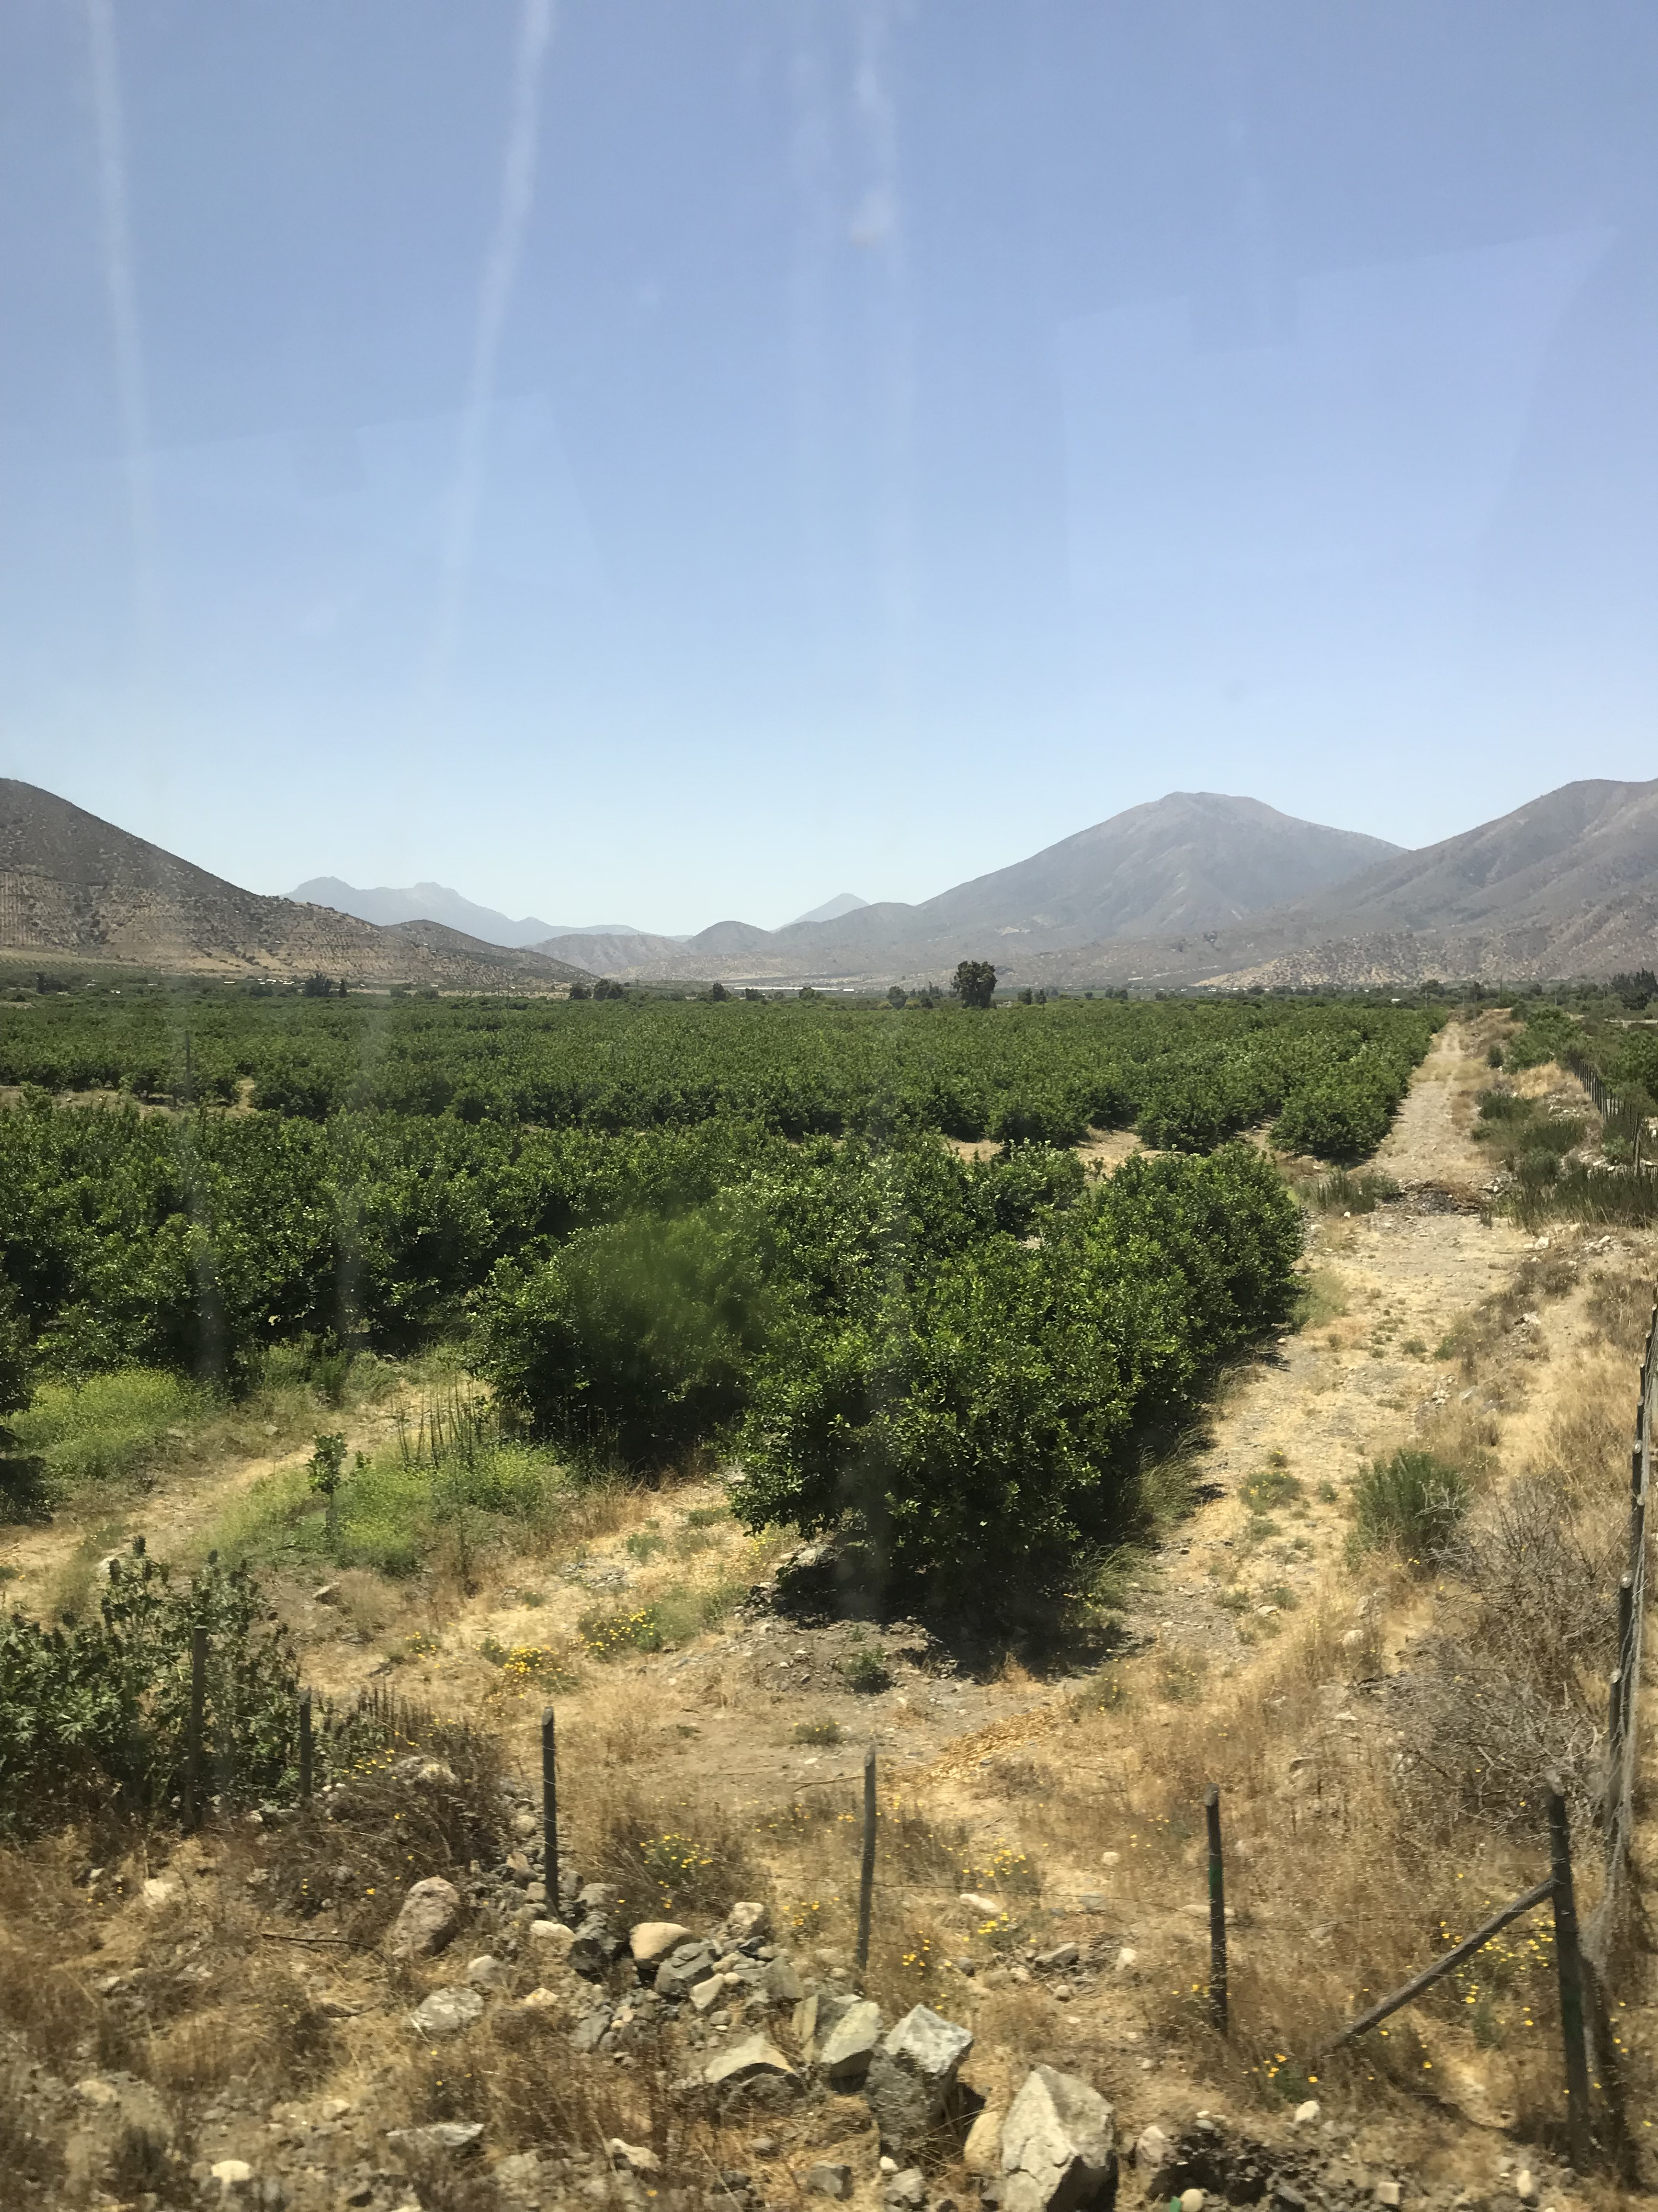

Avocado Farm in Petorca

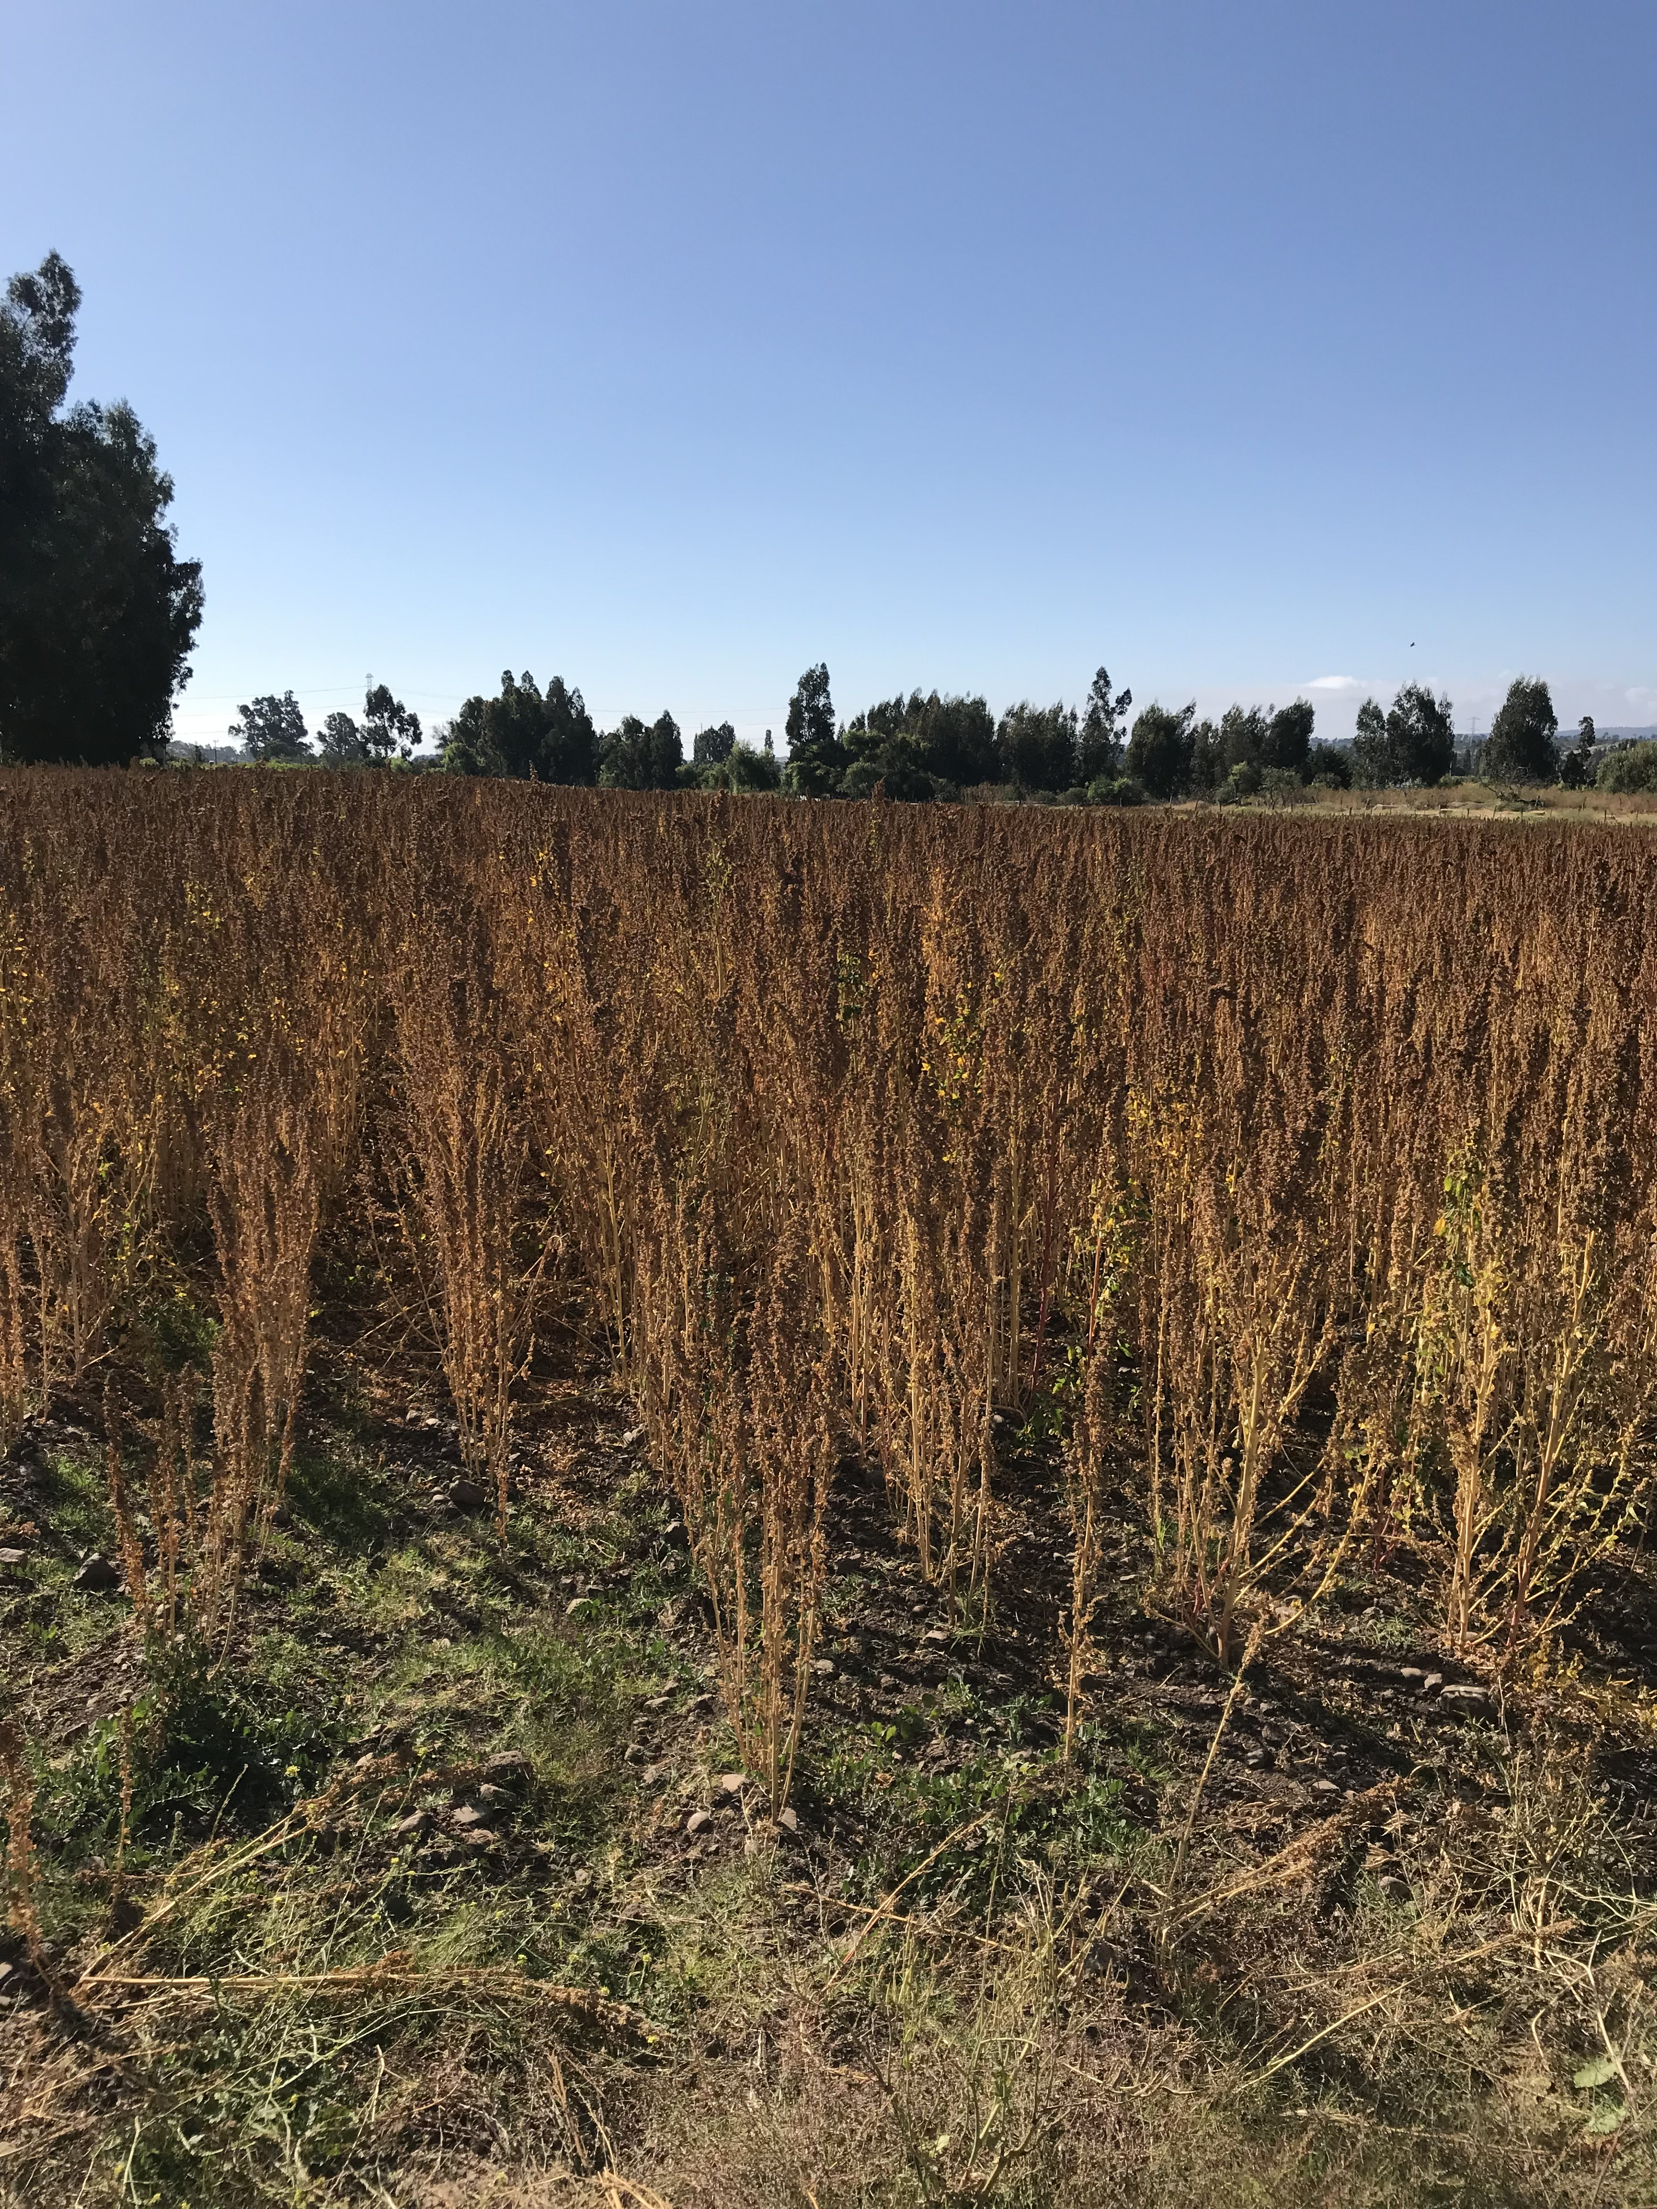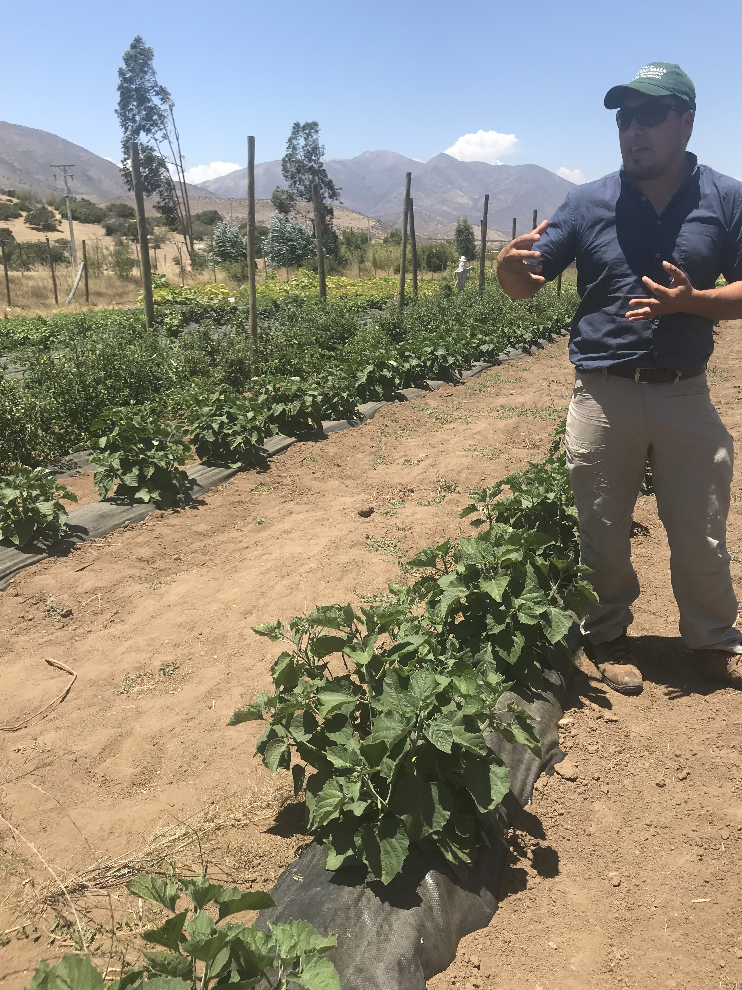

Quinoa Farm

PUCV Agronomist Lecturing

## Lago Penuelas

Sdkjaglkjglkjdgla’ksjgd

## Ventanas and Aguas Claras

Sad;gj;jgd;’jgs;’sdgj

## Santiago

# ACONCAGUA VALLEY CASE STUDY

Case study

Chance constrained LP to illustrate allocation.

4 Users.

Need Denrrohydrology

CONCLUSIONS AND RECOMENDATIONS

REFERENCES

# APPENDIX

1. Welfare in the sense of welfare of a nation – a way to maximize benefit for the entire nation as a whole.